VTC Fall 2022 VA250 Tourism marketing program
This Word Document contains the questions and information within the online application for the VTC Fall 2022 VA250 TOURISM MARKETING Program. This document allows you to see the entire series of questions in the application. You may want to enter your answers in the Word Document, then copy and paste into the online application. This document also contains additional “Helpful Tips” that can assist with answering the questions to strengthen your application.
NOTE: ONLY ONLINE APPLICATIONS WILL BE ACCEPTED.
 ONLY OFFICIALLY RECOGNIZED VA250 COMMUNITY COMMITTEES ARE ELIGIBLE TO APPLY. THIS APPLICATION HAS AN EXTENDED SUBMISSION PERIOD OF 90 DAYS SO THAT LOCALITIES CAN PASS THE REQUIRED RESOLUTION AND IDENTIFY THEIR VA250 COMMITTEE. A COPY OF THE RESOLUTION IS REQUIRED WHEN YOU SUBMIT AN APPLICATION. FOR MORE INFORMATION ON THE PROCESS TO BECOME AN OFFICIALLY RECOGNIZED COMMUNITY COMMITTEE, PLEASE VISIT WWW.VA250.ORG
Overview
The Virginia Tourism Corporation (VTC) is pleased to announce that applications are now open for the Virginia Tourism Corporation (VTC) Fall 2022 VA250 Tourism Marketing Program. This program is offered in partnership with the VA250 Commission.
America’s 250th commemoration is 2026-2031. In preparation for those commemoration years, localities are encouraged to begin their planning process by forming an official VA250 committee and creating a plan to promote stories, history, and culture.
PLEASE NOTE: This application for the VA250 Tourism Marketing Program differs from past VTC Marketing Leverage Program applications. Below is a quick overview of the changes:
- Different online application process than in the past.
- One funding tier:
  - $10,000
- Required 1:1 cash match.
- There is NO lookback period with this program. Since this is the first round of a new program with specific themed requirements, no expenses paid before October 24, 2022 may be used as cash match or for reimbursement.
- Partner Requirement – You will need to identify two other partners who you can work with to leverage your marketing dollars. You must upload a letter of support and their financial commitment amount (minimum $250.)
- Only officially recognized VA250 community committees may apply, and a resolution passed by the local governing body must be uploaded with the application.
- Tentatively, the program will be offered twice each year and applicants are encouraged to scaffold and phase a plan for their commemoration in order to access these and other funds over the next several years.
- DMO Requirements: You must identify local or regional DMO and upload a letter of support from the DMO for your program. DMO’s are not required to provide a financial commitment unless they are also acting as a partner in your program.
- Bonus Points are available. Applicants should pay close attention to the bonus point opportunities.
- Competition for this grant program will be STRONG. Please follow ALL directions and answer as completely as possible.
- Due to the anticipated number of applications, and to expedite application approval, a draft review of applications will not be possible.
- Only online applications will be accepted.
- Do NOT send – via email or regular mail – any attachments or supplemental materials. These materials will NOT be reviewed. Only submit the requested and required information via this online application!
Application Instructions
Read the VTC Fall 2022 VA250 Tourism Marketing Program Terms & Conditions. The Terms & Conditions contain information on eligible expenses under this program. Only eligible expenses can be counted for cash match and for reimbursement.
This program allows for LIMITED interpretive signage. Applicants are encouraged to explore the Road to Revolution signage opportunity listed in the Terms and Conditions. However, applications that include interpretive signage MUST also include a marketing component to drive visitation to the sign location and other visitors experiences at that destination.
Refer to the HELPFUL TIPS for pointers on what the VTC Grant Review Team will look for in a competitive application.
You may want to complete the narrative sections on a word document and then cut and paste into the online application.
You will complete the following sections in your application:
- Applicant Information (this would be the official VA250 certified community committee)
- Partner Information, financial commitments, and letters of support
- Cash Match Marketing Plan
- Marketing Plan (items for which you are seeking VTC reimbursement), including interpretive sign draft text/images if your marketing plans include interpretive signage
- Performance Measures
- Bonus VIFL Activation
- NOTE: In the fields of the application, a “plus sign” indicates that you can click on the “plus sign” to allow you to enter additional items for that section.
VTC fall 2022 va250 tourism marketing program
VERY IMPORTANT: Your application information is saved on our server as you enter it. If you need to leave the application, scroll to the bottom of the application, and click “Save and Continue Later”. You will receive a unique URL that will allow you to go back into the application to make edits. BE SURE TO COPY THIS URL SO THAT YOU CAN GO BACK TO EDIT YOUR APPLICATION! You also can enter your email address and have the link sent to you. You will need to follow this procedure each time you leave the application in order to save your work.
Once you are ready to submit the Final Version, you will acknowledge the Acceptance of Terms. A SUBMIT button will appear. At that point you may submit your application. Please note that once you submit, you will NOT be able to make any revisions to your application.
DEADLINE INFORMATION
- Applications are due by 5:00 PM on Tuesday, January 24, 2023
- NO extensions to this deadline will be possible.
- Award announcements should be made by mid-April 2023
APPLICANT Information
HELPFUL TIPS for Contact Information; Completion Date, and Requested Funds
- Be sure to complete ALL sections of the Contact Information, including your Federal Employer Identification Number (FEI#)
- Indicate when you anticipate the completion of your marketing program. All programs should be completed within 18 months of award notification.
- Indicate the amount of funding you are requesting (max. $10,000.) This amount should equal the amount of your total Marketing Plan Budget. You Cash Match Marketing Plan section should at least equal the amount of your request as well.
- You must upload a copy of your locality’s VA250 resolution indication the committee designation.
- Information on how to form a copy and a sample resolution can be found here: https://va250.org/form-a-local-committee/
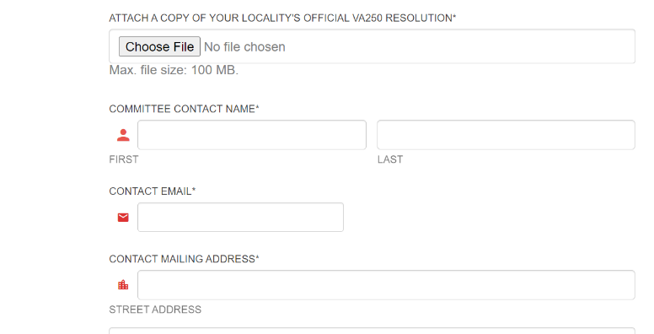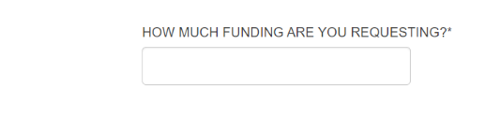
HELPFUL TIPS for Program Focus
- Select an appropriate name for your marketing program
- Describe your program in detail making sure you reference your marketing plan, VA250 themes, and your program goals.
- Select your program start and end date (max. 18 months)
- List and explain the goals of your program.
- Explain how this program connects with the VA250 themes
- Explain how this program will continue past the program end date.
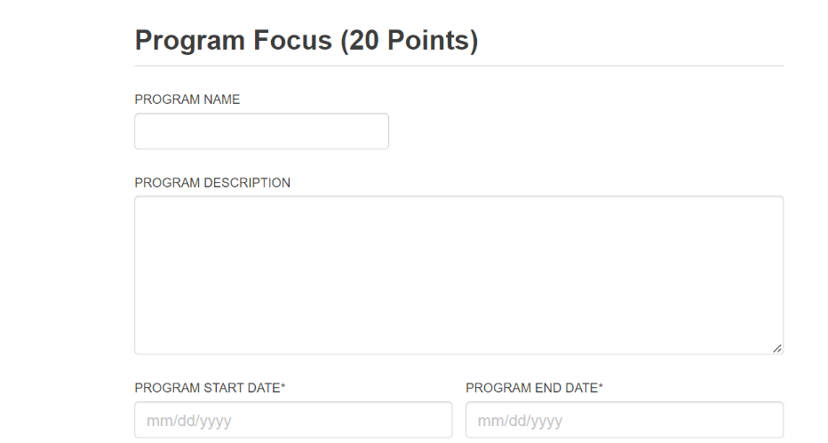
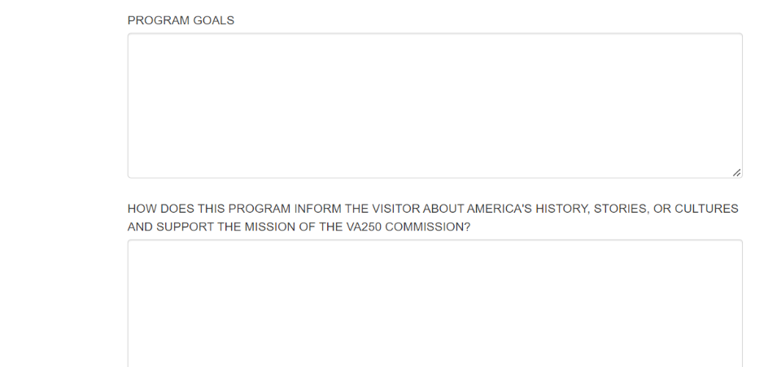

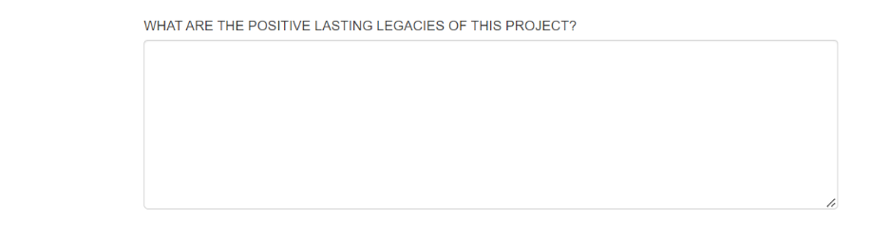
PARTNERSHIPS (15 POINTS)
HELPFUL TIPS for Partnerships section
- Explain how this program will drive overnight visitation. You may want to look at VTC’s visitor profiles at www.vatc.org/research to see what types of travelers are coming to your destination and how their interests connect with your program focus.
- Explain how your program can be a platform for partnerships with organizations, lodging partners, culinary partners, and other tourism-oriented businesses.
- Your local DMO can assist with your business or organization marketing. The DMO is the principal organization that works to attract visitors to your area.
You should engage with your DMO on a regular basis. For this grant application, please indicate your local or regional DMO and upload a letter of support for this program. If the official VA250 community committee is the DMO, a letter of support should still be uploaded. A list of DMOs can be found here: https://www.vatc.org/wp-content/uploads/2022/09/DMOlist.pdf
- Identify two partners for your program and their individual financial commitment (minimum $250 per partner) and upload letters of support from those partners.
- Indicate how these partners will support your program with their financial contribution and beyond their financial contribution.

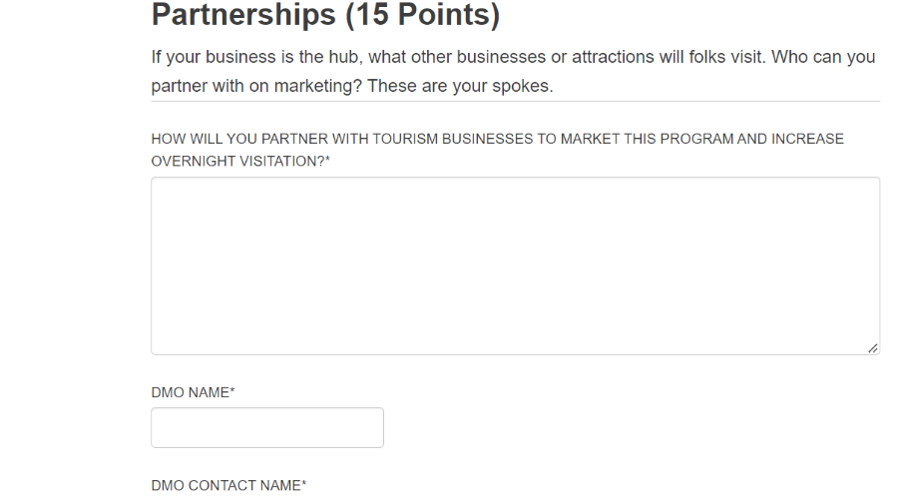
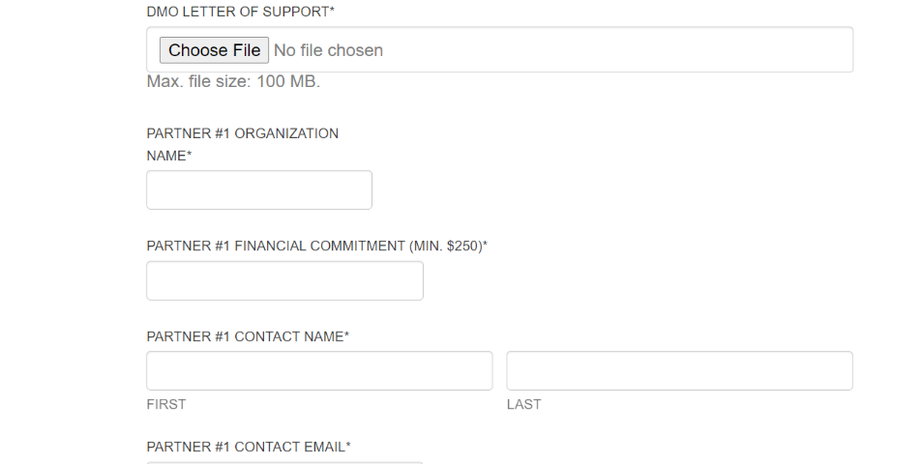
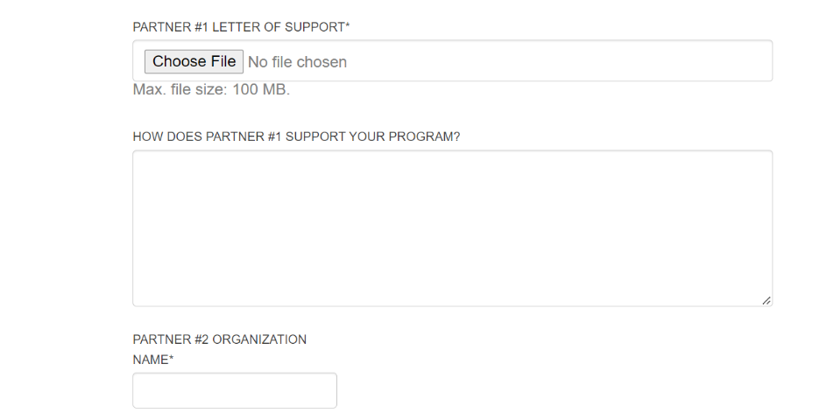
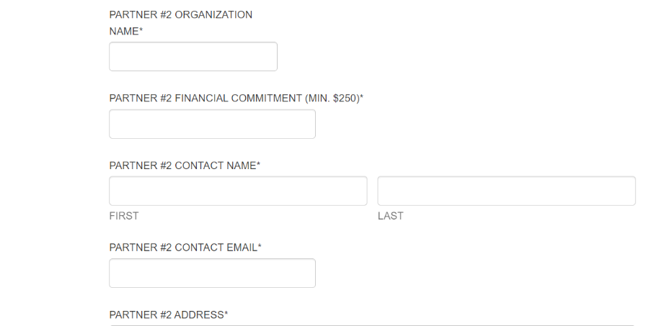
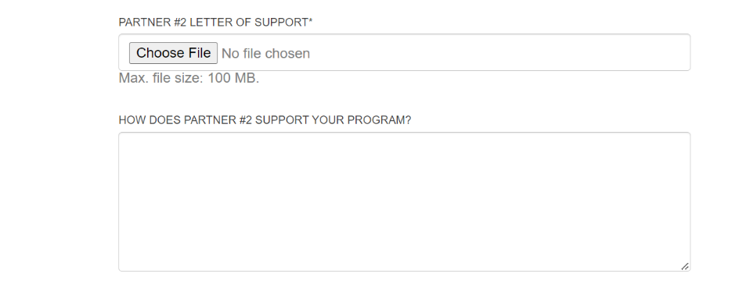
cash match marketing plan (20 points)
For this round of the VTC VA250 Tourism Marketing Program, you must have 1:1 cash match.
To receive a full $10,000 award from VTC, your Cash Match section must equal at least $10,000.
NOTE: Non-marketing value expenses, such as office space, CANNOT be used as cash match. ONLY eligible items listed in the VTC VA250 Tourism Marketing Program Terms and Conditions may be used for match and ONLY expenses incurred on or after October 24, 2022, may count as match.
HELPFUL TIPS for CASH MATCH VALUE
- You may use your existing, Paid Media marketing budget items as match value for this section.
  - For example, if you place a ¼ page ad in Blue Ridge Outdoors four times a year and the total cost is $5,200, you can list this as an in-kind match with a value of $5,200.
- Prior awards from other VTC grant programs cannot be used as match.
- Since this is a new program, there is no lookback period due to the focus on VA250 themes.
- The system will allow you to add 10-line items.
- Select from the dropdown boxes the description that best fits that line item.
- Make sure your placement dates are within your program date window.
- Thoroughly describe the line items including describing physical placement, themes, and graphics if interpretive signage and thoroughly describing target markets and demographics if a marketing item. For Welcome Center/PMAP line items, be sure to indicate the Welcome Center(s) you are selecting and the # of months of placement at each center in the description.
- NOTE: When entering the dollar value of your Cash Match, enter as a whole number, without the dollar sign, and without a comma. Example: 1535
- REMINDER: USE WHOLE NUMBERS; NO DOLLAR SIGNS, DECIMALS, OR COMMAS.
- IMPORTANT: PLEASE DOUBLE CHECK YOUR MATH ON THE TOTALS. IF YOU EDITED A LINE ITEM, BE SURE TO CLICK BACK THROUGH THE BOXES SO THE GRAND TOTALS UPDATE.
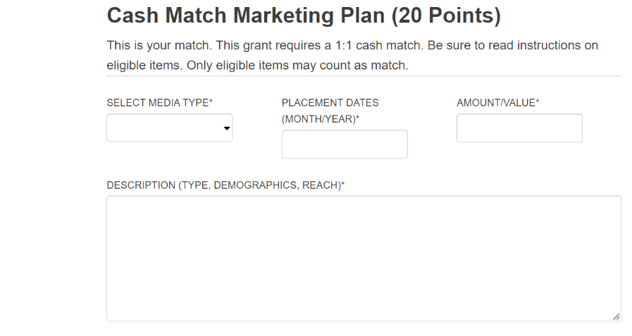

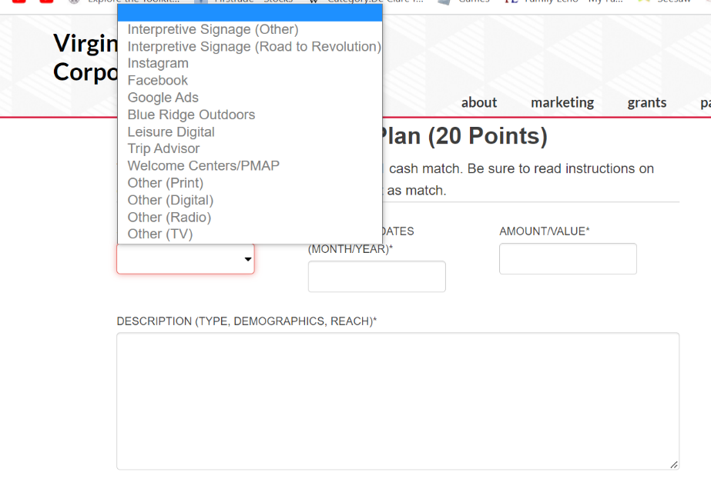
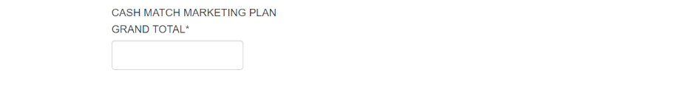
Marketing Plan (20 points)
Your marketing plan will help bring your idea to life. In this section, we want to hear how you will promote your program through strategic marketing efforts. Show us an integrated approach to promoting your campaign by thinking about the best places to amplify your message and reach your intended audiences. Please list specific media placements, date of placement (month/year) and cost. Be as detailed as possible.
HELPFUL TIPS for your MARKETING PLAN
- In this section, you will tell us what your marketing plan is.
- You may use your existing, Paid Media marketing budget items as match value for this section.
  - For example, if you place a ¼ page ad in Blue Ridge Outdoors four times a year and the total cost is $5,200, you can list this as an in-kind match with a value of $5,200.
- Marketing line items being reimbursed from prior awards from other VTC grant programs cannot be used as line items in this marketing plan.
- Since this is a new program, there is no lookback period due to the focus on VA250 themes. Only placements on or after October 25, 2022 are eligible for reimbursement.
- The system will allow you to add 10-line items.
- Select from the dropdown boxes the description that best fits that line item.
- Make sure your placement dates are within your program date window.
- Thoroughly describe the line items including describing physical placement, themes, and graphics if interpretive signage and thoroughly describing target markets and demographics if a marketing item. For Welcome Center/PMAP line items, be sure to indicate the Welcome Center(s) you are selecting and the # of months of placement at each center in the description.
- If your marketing plan includes interpretive signage, please upload a draft of the proposed texts and images. If images are not yet available, describing the images is acceptable. We understand the text may change as you work with historians and sign contractors.
- NOTE: When entering the dollar amount of your budget items, enter as a whole number, without the dollar sign, and without a comma. Example: 1535
- REMINDER: USE WHOLE NUMBERS; NO DOLLAR SIGNS, DECIMALS, OR COMMAS.
- IMPORTANT: PLEASE DOUBLE CHECK YOUR MATH ON THE TOTALS. IF YOU EDITED A LINE ITEM, BE SURE TO CLICK BACK THROUGH THE BOXES SO THE GRAND TOTALS UPDATE.
- The total Budget Amount should at least equal your Requested Funds. It is okay if your Total Budget Amount exceeds your Requested Amount, but the maximum award for this grant will be $10,000.
- VTC Industry Advertising Co-Op Program & PMAP Program
  - More information on the VTC Co-Ops is available at https://www.vatc.org/marketing/advertising/partneradvertising/
  - More information on the VTC PMAP program is available at:
https://www.welcomeva.com/
- NOTE: Do NOT send via email or regular mail any attachments including existing marketing plans or other materials. You MUST complete the marketing plan using the format below. Any email submissions WILL NOT be reviewed.
at
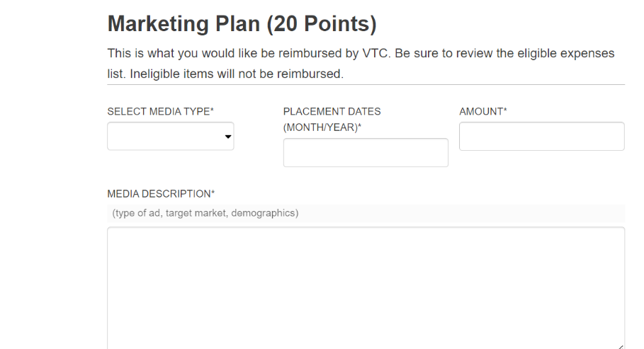
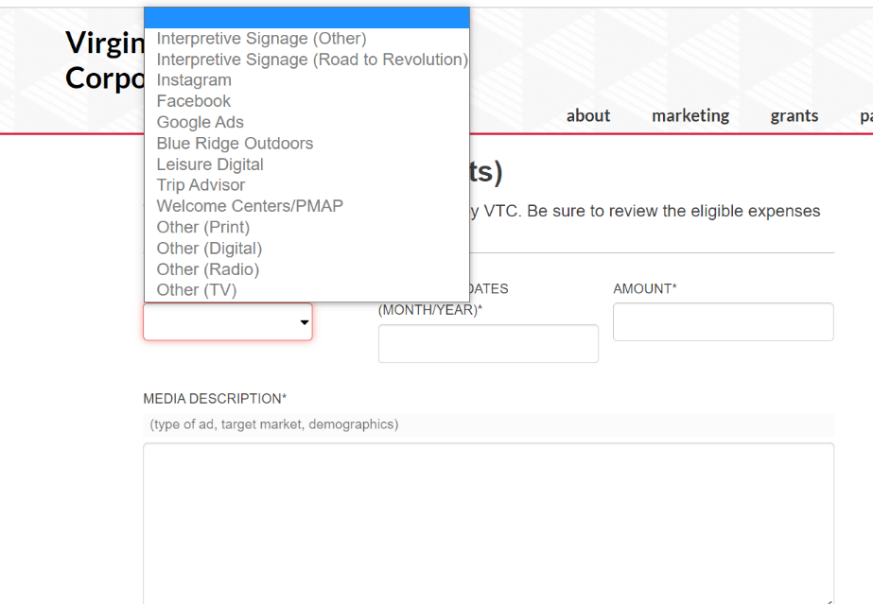
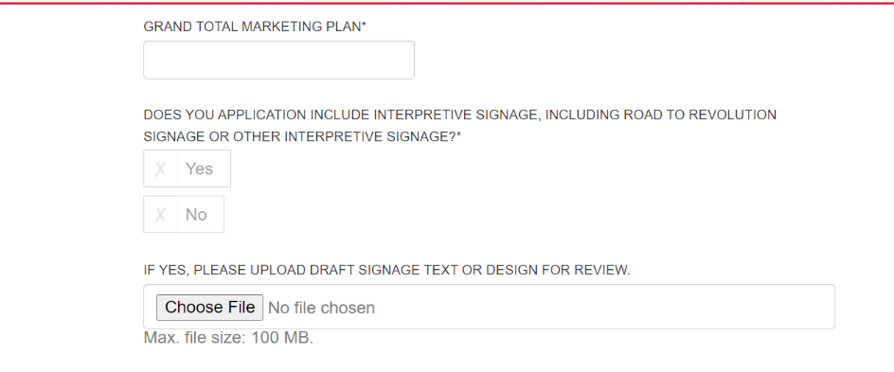
PERFORMANCE MEASURES (20 POINTS)
In this section you will tell us how you will know if you are successful. Please state at least three ways you will measure the success of your program, where those numbers are today, and where those numbers should be in one year. This section will be used when you submit your final report at the end of your program. You may add applicable Performance Outcomes as needed.
HELPFUL TIPS for your PERFORMANCE OUTCOMES
- In order to know if you are successful, you need to establish ways to measure your success.
- The hope is that your marketing program will generate more visitation, occupancy and/or revenue AS WELL AS MORE SUPPORT FOR YOUR VA250 INITIATIVES.
- This can be as simple as identifying a few items to keep track (your metrics); identify what those numbers are today (your baselines), and where you hope to be in the future (your goals).
- In this section you will let us know how you will measure your success.
- A couple of examples are:
  - Metric Baseline Goal
  - Attraction Visitation 2,500 3,000
  - # of Event Sponsors 3 5
  - Occupancy 100 rooms 110 rooms
  - Meals Tax Revenue $750 $1200
- Complete the section below with your Performance Outcomes
- The system will allow you to three Performance Outcomes from the drop down box in each line item.
- In this section you must also indicate how you will continue this project after this funding cycle. For instance, if you are installing interpretive signage, how will continue to promote the sign location and nearby visitor experience throughout the commemoration years?
- You must also indicate your plan for implementing this project if your application is not fully funded. Will you work on finding sponsors? Will you reduce your marketing outreach? Will you allocate additional cash match to cover the reduced award?
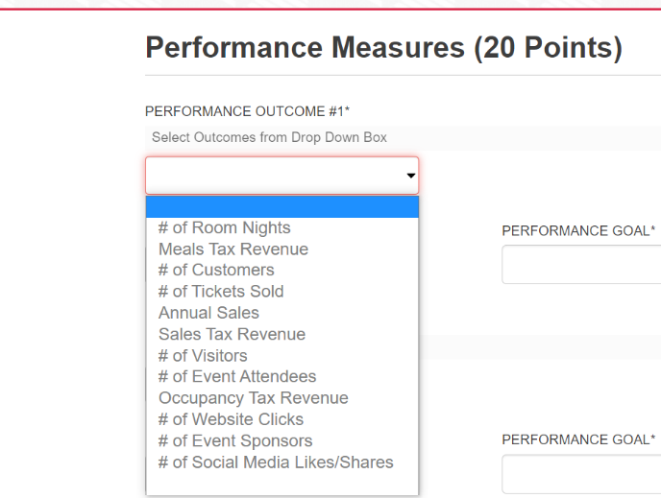
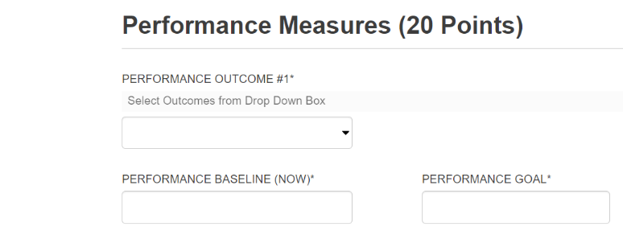
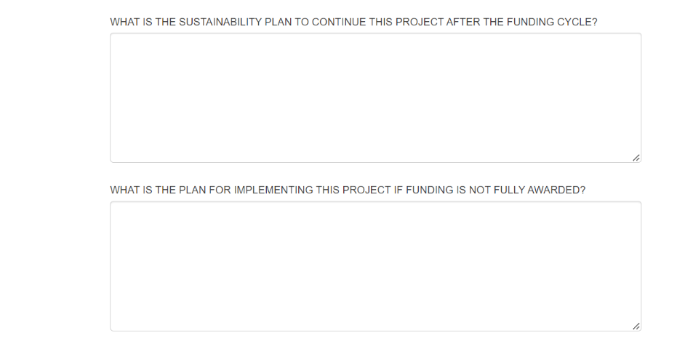
BONUS POINTS (5 bonus points)
HELPFUL TIPS to receive up to 5 BONUS POINTS
- You can receive up to 5 Bonus Points added to your grant score by indicating below how you will integrate aspects of the VA250 & Virginia is for Lovers campaigns into your marketing.
- If you chose VTC Co-Ops or PMAPs as part of your marketing plan, then be sure to list those again in the section below.
- All campaigns offer opportunities for our partners to participate by providing partner toolkits, logo treatments, creative templates, and sample messaging.
- More information on the Virginia is for Lovers campaigns is available at https://www.vatc.org/marketing/advertising/brandinitiatives/, and below in the application.
- Activating the VA250 & Virginia is for Lovers brand on-site or through your social channels is an opportunity to be creative. This is what you would do beyond the requirement that the VA250 & Virginia is for Lovers logo be included in your marketing collateral for reimbursement. Think about how you can integrate the brand in unique ways such as having performers wear VA250 & Virginia is for Lovers apparel, having banners on site, or possibly including VTC on PR/photography opportunities related to your campaign.
- If you are having a major event, performance, or exhibit you can receive bonus points for uploading photos and B roll to VTC’s Widen photography sharing site.
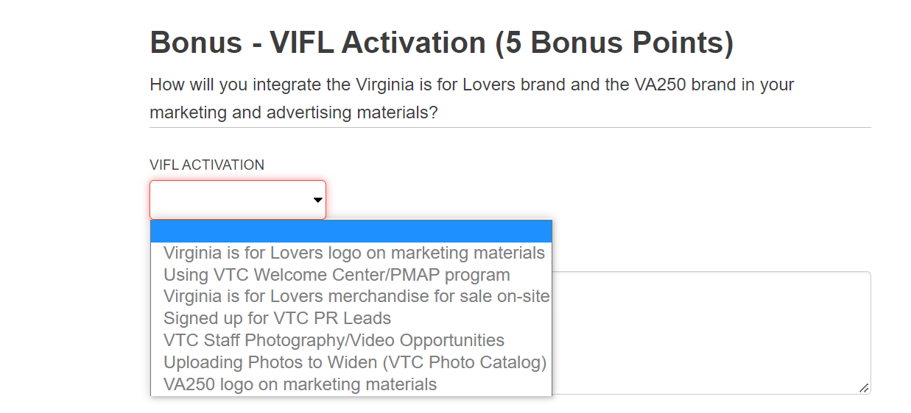

SUBMITTING YOUR APPLICATION
VERY IMPORTANT:
- Your application information is saved on our server as you enter it.
- If you need to leave the application, scroll to the bottom of the application and click “Save and Continue Later”.
- You will receive a unique URL that will allow you to go back into the application to make edits. BE SURE TO COPY THIS URL SO THAT YOU CAN GO BACK TO EDIT YOUR APPLICATION!
- You also can enter your email address and have the link sent to you.
- You will need to follow this procedure each time you leave the application in order to save your work.
Once you are ready to submit the Final Version, you will acknowledge the Acceptance of Terms.
- A SUBMIT button will appear
- At that point you may submit your application.
- You will receive a confirmation screen and you will receive a PDF of your application.
- Please note that once you submit, you will NOT be able to make any revisions to your application.
DEADLINE INFORMATION
- Applications are due by 5:00 PM on Tuesday, January 24, 2023
- NO extensions to this deadline will be possible.
- Award announcements should be made by mid-April 2022

